Merlin1X

The high speed photon counting detector.
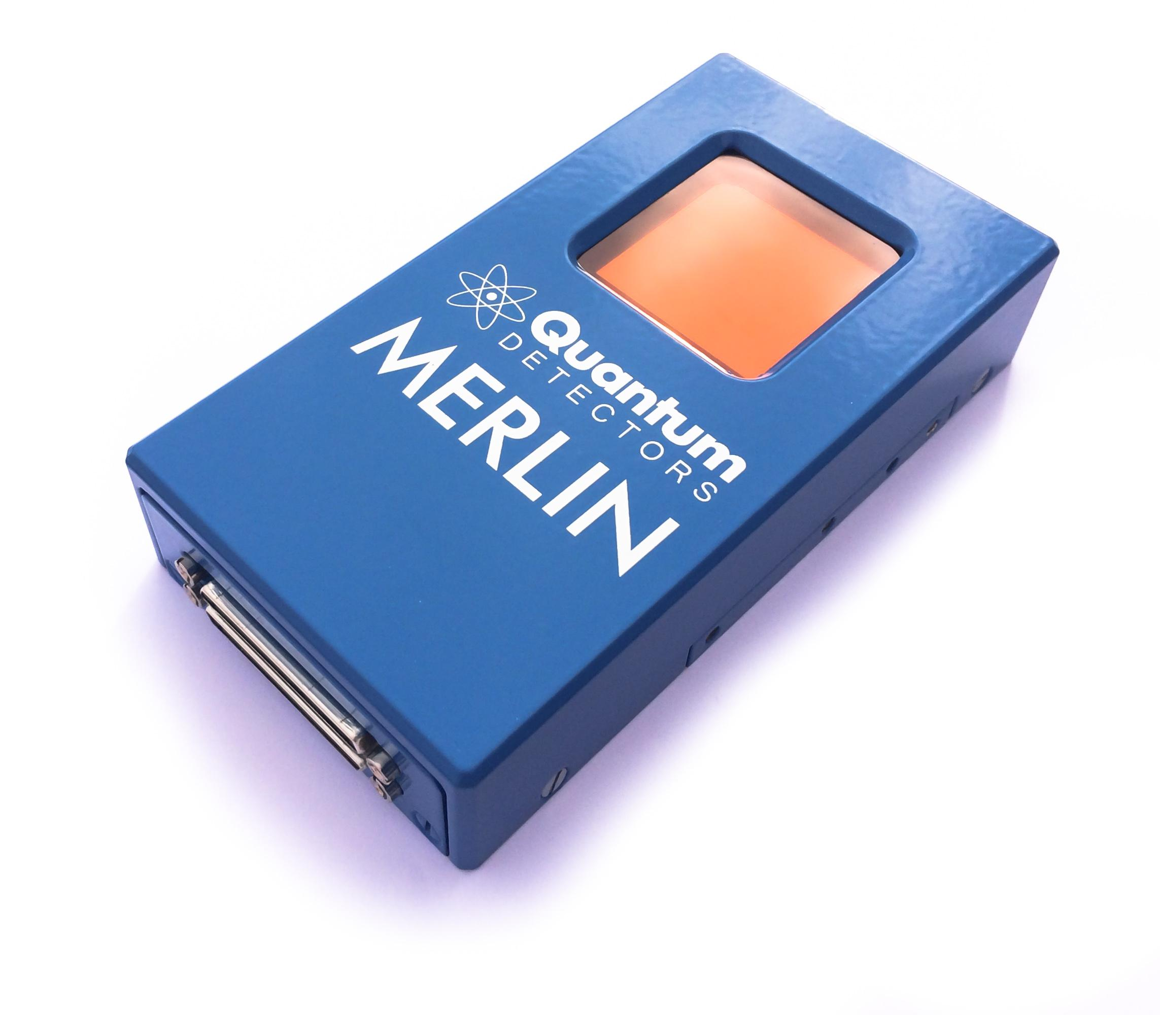About
Merlin, developed by Diamond Light Source, is a robust and versatile system built around the Medipix3 ASIC. It is designed with the high performance and reliability standards required by synchrotron beamlines and other industrial and large scale scientific applications.
Multiple Configurable Counting Modes
The on board Medipix3 ASIC has a large array of configurable features that allow a number of powerful and novel counting modes:
Zero Readout Dead Time By alternating the two counters available to each pixel, the system can be continuously sensitive with no readout dead time at all. Whilst one counter is acquiring an image the other is reading out.
Extremely Deep 24 bit Counter By connecting the two counters together a single 24 bit deep counter is produced. This, coupled with the small 55μm pixel size produces very high dynamic range imaging. Very faint signals can now be measured immediately adjacent to very intense features.
Two Simultaneous Energy Thresholds By providing a second threshold for the second counter it is possible to use the system in an energy windowing mode. By recording images of photons that fall between two adjustable energy levels, specific signals can be studied or known sources of noise can be rejected depending on their energy.
Charge Summing Mode In the circumstances where the charge from an event falls on the boundaries between sensor pixels, the information is shared between the pixels and the event is reconstructed. This significantly increases the accuracy of the spectroscopic information where some below threshold data would normally be lost or lower energies would be recorded.
Compact size. The small size and power consumption of the Merlin detector head, coupled with its room temperature operation allows it to rely on ambient cooling through the detector head housing. It therefore requires no cooling fluids or gas to be supplied. This makes the system very self contained and easy to install and reposition.
Technical specifications:
ASIC Medipix 3RX
Pixels 256 by 256 pixels
Pixel size 55μm by 55μm square pixels
Sensor area 14 mm by 14 mm
Sensor thickness 500μm
Sensor type Reverse biased hybrid silicon diode array
Dynamic Range 1, 6, 12 bit or 24 bit configurable
Deadtime in continuous mode Zero
Maximum frame rate: 21,000 fps (1 bit mode), 3,600 fps (6 bit mode), 1,825 fps (12 bit mode)
Threshold range 5 keV upwards
Cooling air cooled
Operating Temperature 10 – 50 C
Communication cable type VHDCI
Communication cable length 1m to 5m
Software: Labview GUI and TCP/IP control
Includes: PC, readouts electronics, and everything required for operation

